# EncoderVelocity

# Aim of the Software

The software should receive encoder position over two time steps and should then calculate the speed of the actuator the encoder position refers to.

# Unit Test:

Appears to calculate correctly in test arena but some noise which may need filtering later. Noise becomes more significant at higher speeds

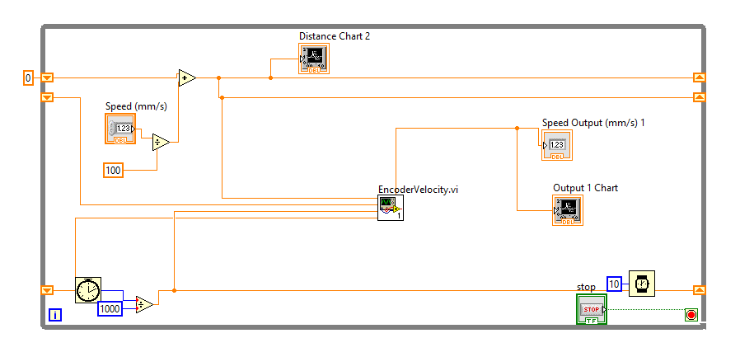

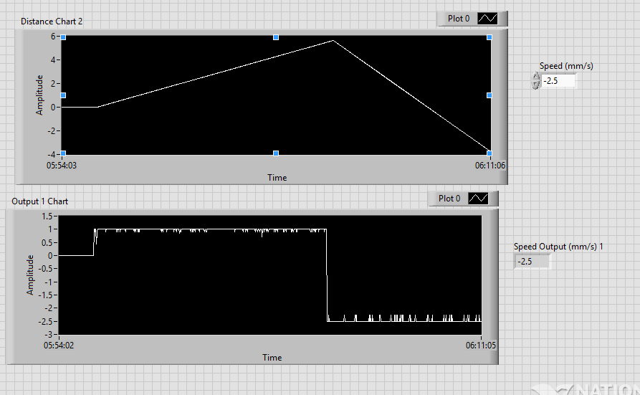

# Integration Testing:

The block was deployed in the manipulator main VI with a wait time of 1ms and tested with the Y axis stepper motor by running the Y-axis stepper motor at 5000Hz for 10 seconds.

Using the Y axis encoder to measure the distance travelled (30.2514mm) the average speed should be calculated to be 3.02514mm/s.

The waveform image shows that the speed is calculated to be between 3mm/s and 3.4mm/s but exhibits significant noise.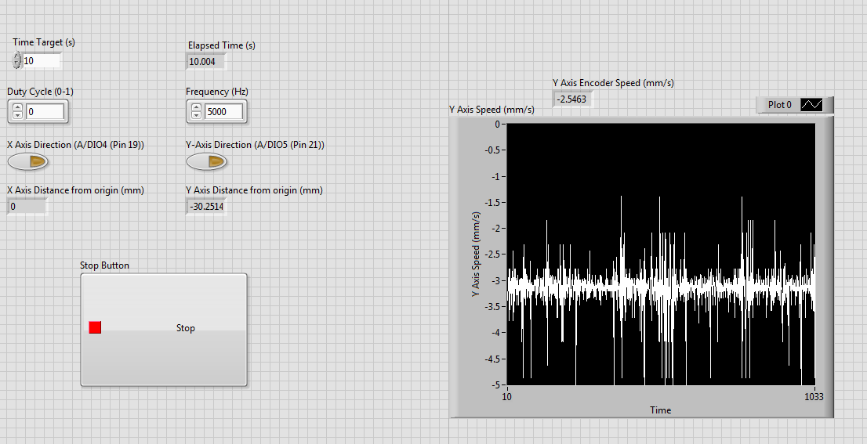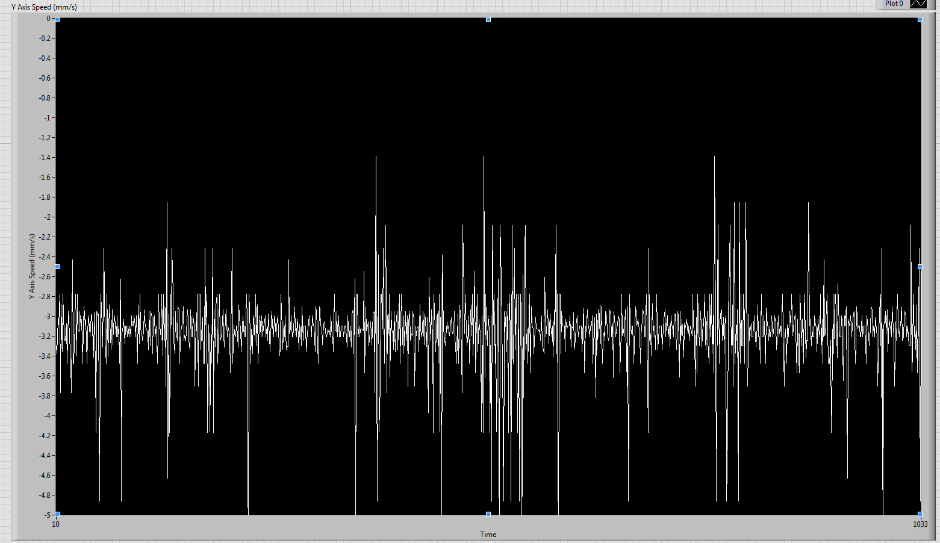

The following screenshots show the same test, but repeated with wait times of 10ms and 100ms.

Wait time = 10ms:

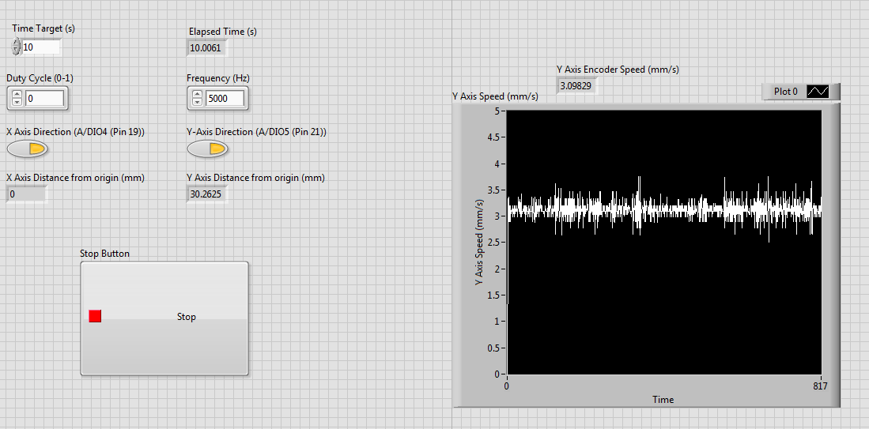

Wait time = 100ms:

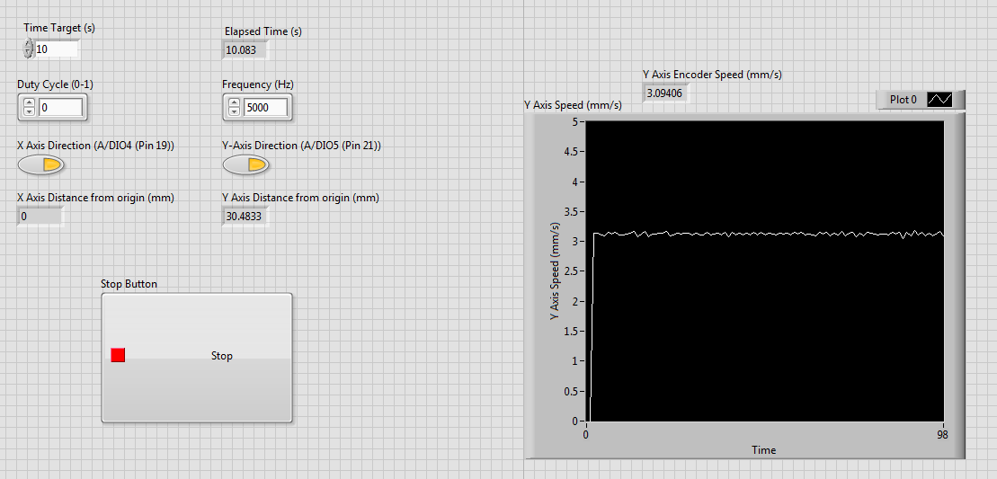

As shown above, the speed calculation is less noisy as the time between data points increases. It would not be appropriate improve the speed calculation by slowing the manipulator runtime as this will later impact other manipulator functionality.

Changing the model sampling time is effectively applying a low pass filter to the data as fast transients are not captured.

Therefore to have a usable speed signal, the data must be low pass filtered.

Below shows an FFT of the data received from the EncoderVelocity.vi running at 1ms turnaround time.

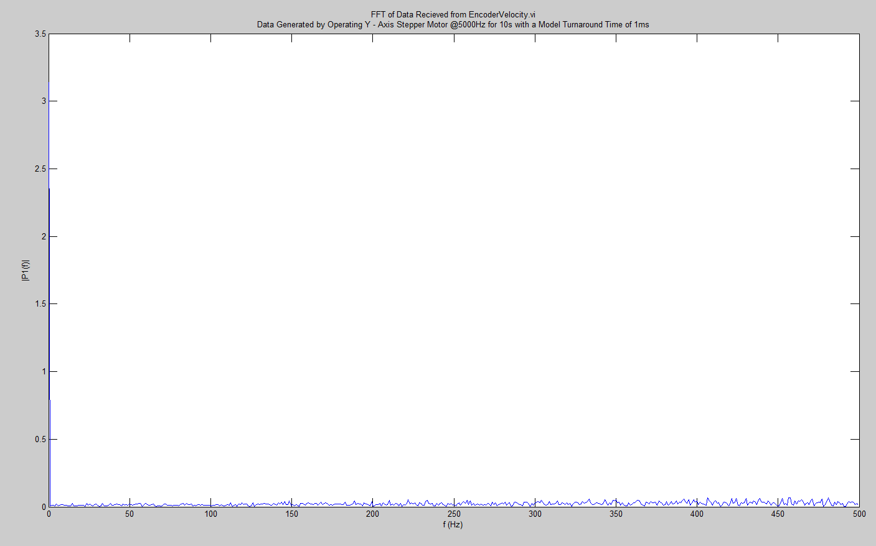

To test whether speed performance can be improved by filtering a smoothing filter with the settings below was used as an initial trial.

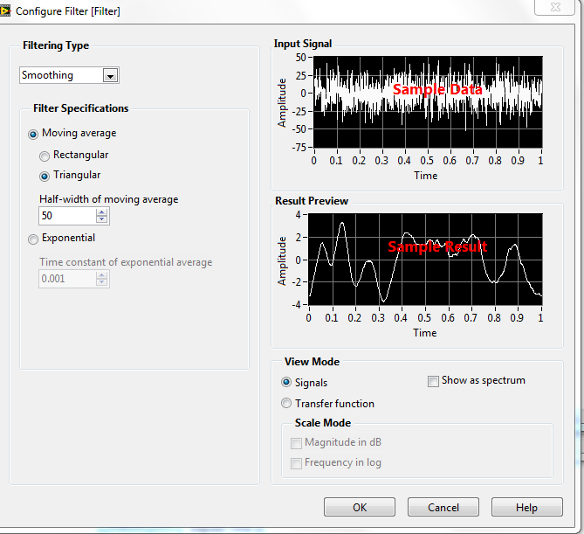

A smoothing filter was used over low pass as noise is apparent across the full frequency spectrum.

The filter was used in the same test where the y axis stepper motor was run for 10 seconds with a turnaround time of 1ms. The encoder speed of 3.14mm/s matches well to the average speed of 3.12mm/s.

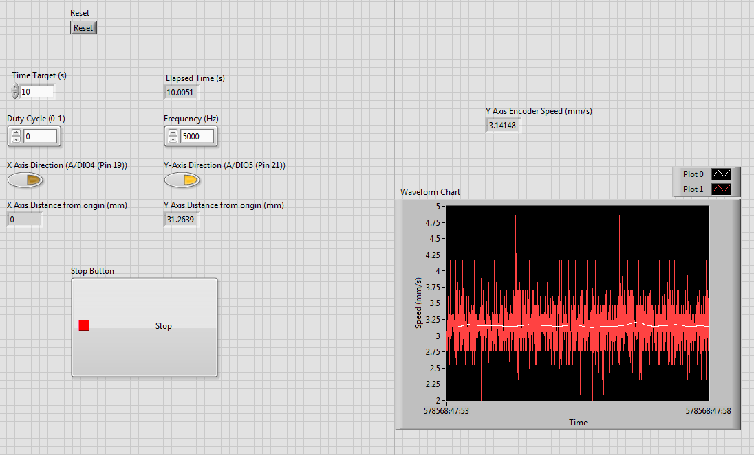

It can be said that the EncoderVelocity.vi works in integration testing and filtering will be taken care of in a separate VI.